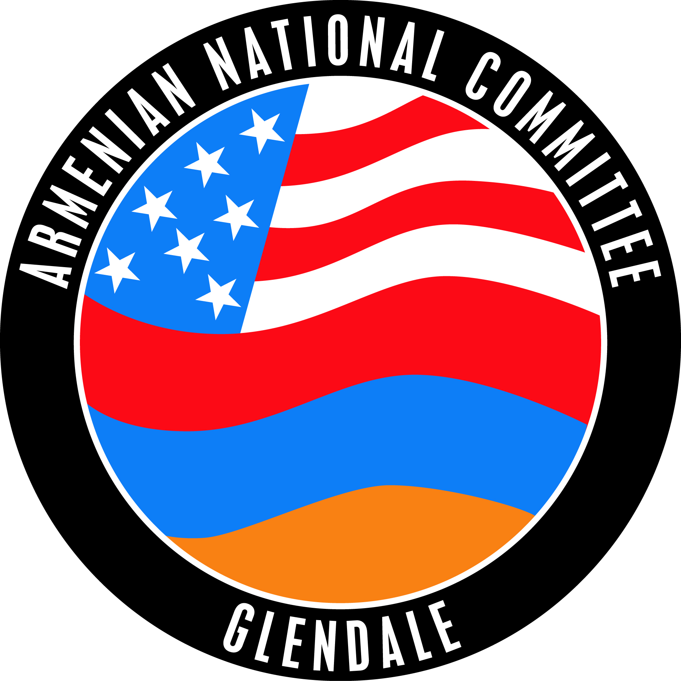
Armenian National Committee of Glendale
Political Action Committee

Potential Topics for Discussion at Interview:
As mentioned in the cover letter, the PAC will review the candidate biography form and
ask additional questions in an effort to explore your vision and views related to these important topics:

- Leadership and Accountability
- Community Outreach
- Budget/Finances
- Safety
- Diversity/Cultural Sensitivity in City Government
- Housing/Development
- Arts and Culture Development/Parks

